Yorkshire Lido Cycle day #2

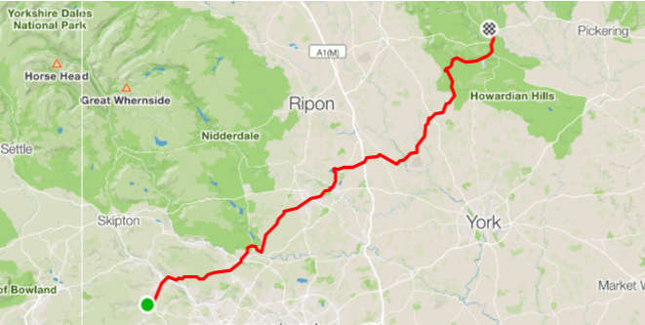
 | Proceed on Longlands drive
 | Left onto Lees Lane | 0.2
 | Left onto Halifax Road | 0.8 |  | At Copper Dragon Pub
 | Continue on A629 |  |  | towards Keighley
 | Right onto Worth Way | 4.2 | Keighley | At KWIK FIT
 | Right (3rd exit) roundabout B6265 | 5.9 | Keighley | Continue on B6265 Bradford Road
 | Left onto Swine Lane | 8.3
 | Follow road right onto Carr Lane | 8.7 |  | Continue towards Otley via Menston
 | Right onto Piper Lane | 21.4 | Otley
 | Left onto Manor Square | 22.2 | Otley | At Barclays Bank
 | Bear right onto Clapgate |  | Otley
 | Bear left onto Bridge Street |  | Otley | At Royal Oak. Continue over the river
 | Right onto Farnley Lane | 22.7 |  | OTLEY LIDO SITE SITUATED HERE IN WHARFEMEADOWS PARK
 | Continue on Farley Lane |  |  | towards Leathley
 | Left onto Leathley Lane | 27.1 |  | Continue on B6161 towards Beckwithshaw
 | Right onto Otley Rd/B6162 | 35.6 | Beckwithshaw | At Beckwithshaw Primary School
 | Continue on B6162 towards Harrogate
 | Join A59 Knaresborough at roundabout | 40.7 | Harrogate
 | Bear left onto A6055 | 44.8
 | Right onto Farnham Lane | 48.2
 | Left onto A168 | 53.1 |  | Over A1
 | Right onto Braimber Lane | 54.0
 | Right onto B6265 | 57.0
 | Left onto Broad Gate | 57.4 |  | Towards Great Ouseburn
 | Left onto Boat Lane | 60.2 |  | Continue through Alne towards Easingwold
 | Left onto Oulston Rd | 74.3 | Easingwold | Towards Oulston then Coxwold
 | Right | 83.1 | Coxwold | Towards Byland Abbey then Wass
 | Right at Wombwell Arms | 86.4 | Wass | Towards Ampleforth
 | Left onto B1257 | 93.1 |  | Towards Sproxton
 | Right onto A170 | 94.6 |  | Towards Helmsley
 | Left at roundabout | 96.7 | Helmsley
 | Right onto Church Street | 96.9 | Helmsley
 | Right onto Cannon’s Garth Lane | 97.0 | Helmsley
 | Left onto Beckdale Rd | 97.1 | Helmsley
 | Continue on Baxton’s Sprunt | 97.2 | Helmsley
 | Arrive Helmsley Open Air Pool | 97.5 | Helmsley

