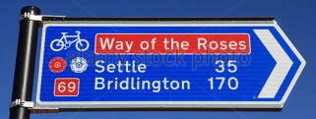
Yorkshire Lido Cycle day #1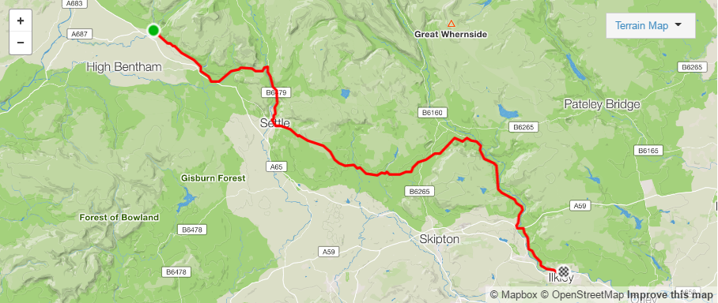
Day #1 follows the ‘Way of the Roses’ route for approximately 40km (Clapham to Burnsall)
Distance 66.8km (41.5 miles) Elevation gained 1164m (3819 feet)

 | Proceed onto Sammy Lane
 | Continue on The Square
 | Left onto Seed Hill
 | Continue; High Street, Old Road, Clapham Old Road, Jenkin’s Bridge, Clapham Old Road, Old Road,
 | Right Cross Haw Lane | 6.3
 | Left B6480 | 6.7 | Clapham | From Clapham follow @Way of the Roses route to Burnsall
 | Left onto Old Road | 6.8
 | Continue on B6480 | 7.0 |  | Follow road around Cave Rescue
 | Continue on A65 | 8.2 |  | Towards Austwick
 | Leave A65 towards Austwick (left) | 8.6
 | Continue on Main Street | 9.7 | Austwick
 | Continue | 9.9 |  | Past Austwick Primary School
 | Continue on B6479 |  | Via; Helwith Bridge & Sainforth | Towards Settle
 | Left onto Penyghent view | 21.1 | Settle | At war memorial
 | Continue; Market place, Cheapside, High Street & Victoria Street
 | Right onto School Hill | 21.7 |  | FEED STATION AT HIGHEST POINT!
 | Continue
 | Right | 31.6 | Scotsthrop/Airton
 | Left onto Calton Lane | 31.7
 | Right onto Hall Brow | 32.4
 | Bear LEFT onto Abbey Hill | 33.3
 | Left onto Winterburn Lane | 35.4
 | Right onto Hills Lane | 35.6
 | Join Fleets Lane | 38.6
 | Continue |  | Via; Cracoe & Thorpe
 | Right onto B6160 | 45.9 | Towards Burnsall
 | Continue |  | Via Burnsall, Barden, Bolton Abbey | Leave Way of the Roses @ Burnsall
 | Join A59 | 58.7 | (at Bolton Bridge) | 1st Exit at roundabout
 | Leave A59 (right) | 59.3 |  | Beamsley Lane
 | Continue |  | Via Nesfield | Towards Ilkley
 | Arrive Denton Road Ilkley | 66.8 |  | ILKLEY LIDO

