Cycling the Yorkshire Lidos
Ingleton - Ilkley - Otley - Helmsley
When & Why?
24th / 25th June 2017. Raising the profile / funds of our three open air pools and best hope of a fourth lido – part of a Yorkshire Lidos Weekend. Helmsley & Ingleton Pools are registered charities with Friends of Ilkely & Otley Lidos also charities.
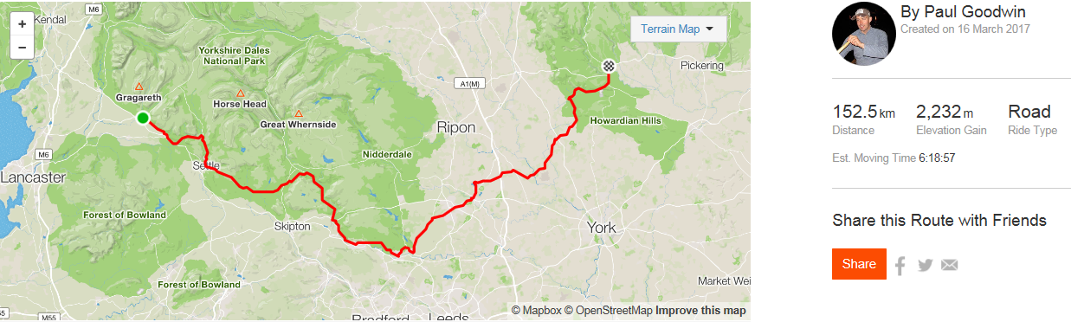
Helmsley Pool’s tank is 48 years old and if it is not refurbished the pool will close. Ingleton are raising funds for a ‘splashpark’ for children and 25 years after the last person swam at the Otley Pool there are ambitious plans for a new lido on the site. Cycling in Yorkshire is increasingly popular and although nationally there are only around 100 lidos left – usage in increasingly.
Format - 95 mile picturesque route to be undertaken in either 1 day (fast riders) or 2 days (leisurely riders) or for non-cyclists a road trip! Cycle between all 4 pools having a swim (distance optional) in 3 of them en-route.
The Pools & Accommodation – there are Youth Hostels in Ingleton and Helmsley and one midway between 7 miles from Ilkley at Haworth
We have booked accommodation at all 3 hostels which is available to participants or they can arrange their own accommodation.
Where / Who
Ingleton Youth Hostel & Swimming Pool LA6 3EG are adjacent to each other – The hostel has been booked Friday 23rd June, Ingleton Pool will provide extra sessions outside of their public swims on both Friday evening and early Saturday Morning.
http://www.ingletonpool.co.uk/ - contact Nigel Thompson ingletonpool@gmail.com and Paul (the Youth Hostel)
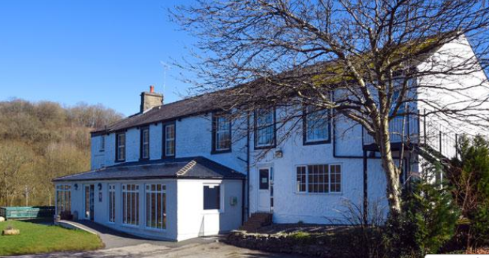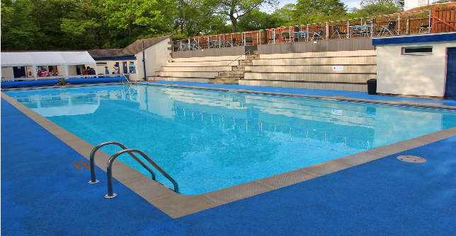
There will be transport from Helmsley via Otley & Ilkley to Ingleton on the Friday evening.
Ingleton Pools opens Saturday 27th May
Ingleton Pool will kindly provide a Water/ Feedstation enroute

Ilkley Lido LS29 0BZ http://www.ilkleylido.co.uk/ Contact Davy – Chair Friends of Ilkley Lido friends@ilkleylido.co.uk
Ilkley Lido is operated by Bradford City Council https://www.bradford.gov.uk/sport-and-activities/sports-centres-and-pools/ilkley-pool-and-lido/ the pool opens 28th May and there is an indoor pool too
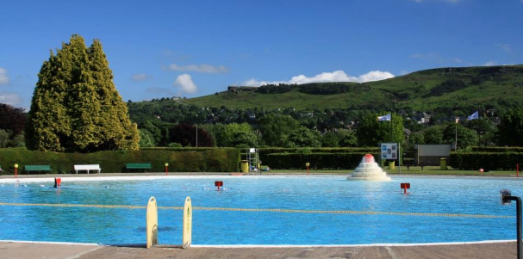
It is 65km (40 miles) to the Ilkley Lido from Ingleton – but this is where the majority of the climbing is.
The Youth Hostel is 11km, 7.5 miles from Ilkely.
There will be a minibus transporting participants belongings from pool to pool. Depending on the weather participants may want to cycle to Ilkley Pool and swim before cycling the last few km to the Youth Hostel – or they can take the minibus from the hostel and return to the pool for the swim.

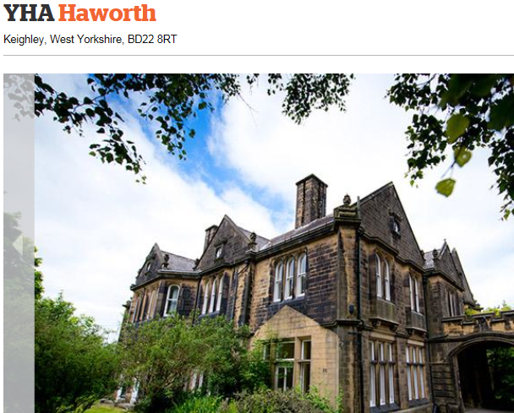

Otley Lido (site of former lido and proposed new one)
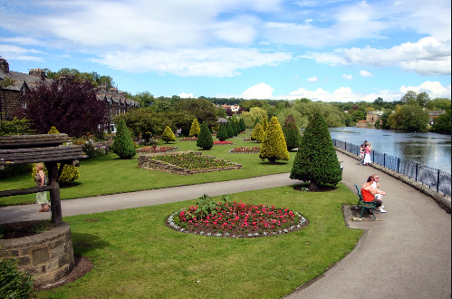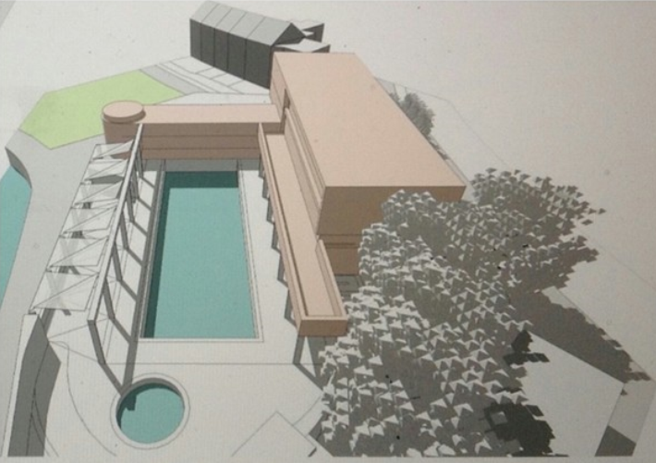
https://www.otleylido.com/
Friends of Otley Lido – Leonie Sharp (Chair) community project to restore the Otley Lido in Wharfemeadows Park. The pool was originally built in 1923 and well used until it closed in 1993.
The cycle route will take in the site and the ‘FOOLS’ will provide a water/feedstation and be available to give tours of the site and provide the latest information on their ambitious plans

Helmsley Open Air Pool & Youth Hostel
www.helmsleyopenairpool.org contact Paul Goodwin info@helmsleyopenairpool.org
Helmsley Pool is a heated 25m pool situated in the North York Moors National Park on the edge of the pretty market town of Helmsley. The pool opened in 1969 and if it is to see its 50th birthday a new tank / lining is required so there is a campaign to ‘save our pool’.
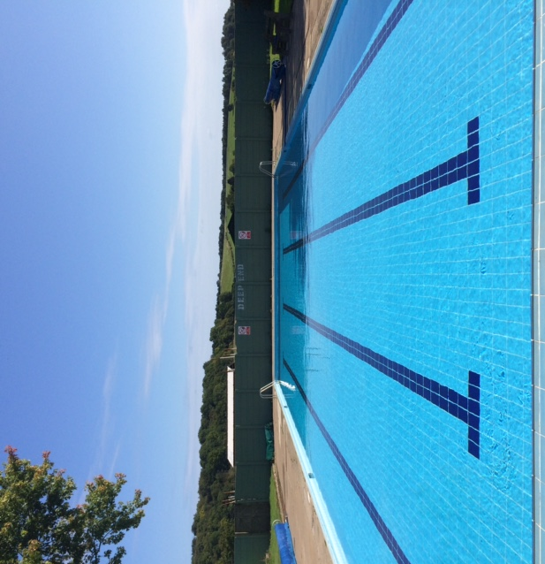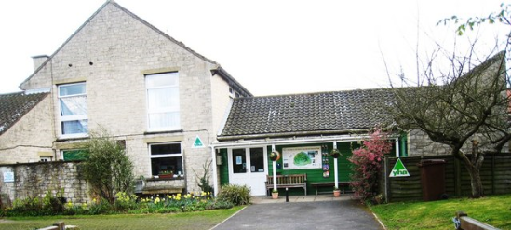
Pool Working Group - Chris Parkin, Carol Swift, Paul Goodwin, Elaine Powley, Rosy Eaton will provide a water / feed station approx 20 miles from the pool. The second days cycling is again mainly on sustrans routes with a stunning descent into Helmsley. The Youth hostel (Warden Neil) has been booked for both Saturday & Sunday evenings.

Proposed Cost Structures / Organisation
Whilst the majority of funds will come from cyclists raising sponsorship and donating through sites like just giving and ‘My Donate’ to the pool of their choice there is the opportunity to raise money by entry / organising the event, which would then be split across the 4 pools. A just giving page has been set up https://www.justgiving.com/helmsley-recreationcharity
Potential Packages (prices are a guide only)
Bronze - £32.45 Entry over the weekend to our 3 pools, goody bag including cycle top, swim cap, water bottle, etc (Hopefully more corporate sponsorship will cover the goody bag costs) Any kit moved from Ingleton to Ilkely/Otley then onto Helmsley. And full cycle mechanical support provided by One Degree West http://www.onedegreewest.net/ The pools will also provide feedstations
Silver - £62.45 1 night / £92.45 2 nights / £122.45 3 nights – As Bronze but with YHA accommodation and YHA Breakfast for either one two or three nights.

Gold - As Silver but with transport one way either to or from Ingleton to Helmsley (via Ilkley/Otely) @ £25 including bike!

What Pools will offer
Warm welcome at the pool / hot drink / potentially stay open longer
Man a feed station approx 20 miles from your pool
First Aid Cover
Promotion of the event
https://www.eventbrite.com/e/cycle-the-yorkshire-lidos-tickets-33543843539

